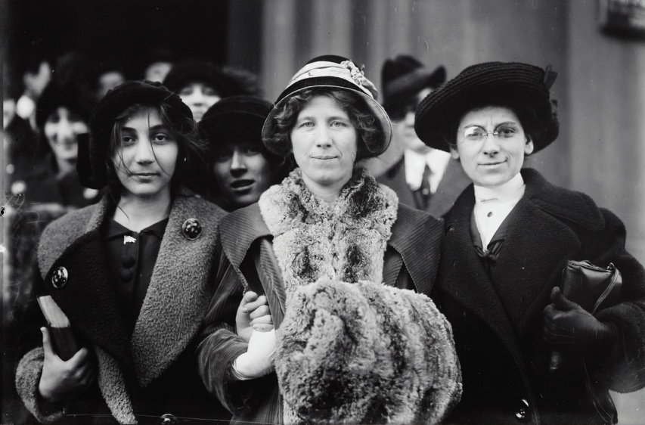

Title：

14-yr. old striker, Fola La Follette, and Rose Livingston

Contributor Names：

Bain News Service, publisher

Created / Published：

1913 (date created or published later by Bain)

Summary:

Summary

Photograph shows suffrage and labor activist Flora Dodge "Fola" La Follette (1882-1970), social reformer and missionary Rose Livingston and a young striker during a garment strike in New York City in 1913. (Source: Flickr Commons project, 2011)

They have all contributed to fighting for women's rights。



#March4Women is a global movement for gender equality: it’s for anyone and everyone who wants to see a more equal world.